Write a query identifying the type of each record in the TRIANGLES table using its three side lengths. Output one of the following statements for each record in the table:

Equilateral: It's a triangle with sides of equal length.

Isosceles: It's a triangle with sides of equal length.

Scalene: It's a triangle with sides of differing lengths.

Not A Triangle: The given values of A, B, and C don't form a triangle.

Input Format

The TRIANGLES table is described as follows:

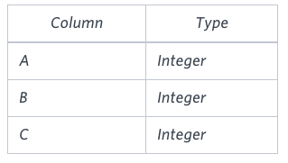

Each row in the table denotes the lengths of each of a triangle's three sides.

**Sample Input**

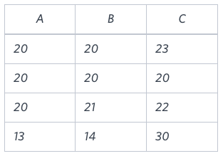

**Sample Output**

Isosceles

Equilateral

Scalene

Not A Triangle

**Explanation**

Values in the tuple (20, 20, 23) form an Isosceles triangle, because A ≡ B.

Values in the tuple (20, 20, 20) form an Equilateral triangle, because A ≡ B ≡ C.

Values in the tuple (20, 21, 22) form a Scalene triangle, because A ≠ B ≠ C.

Values in the tuple (13, 14, 30) cannot form a triangle because the combined value of sides A and B is not larger than that of side C.